Title
Analysis of Data Acquired Using ROC Paradigm and its Extensions

Abstract
A common task in medical imaging is assessing whether a new imaging system or device is an improvement over an existing one. Observer performance methodology, such as receiver operating characteristic (ROC) analysis, is widely used for this purpose. ROC studies are often required for regulatory approval of new devices. The purpose of this work is to describe RJafroc, which implements software for analysis of data acquired using the ROC paradigm and its location specific extensions. It is an enhanced implementation of existing Windows software called JAFROC (jackknife alternative free-response ROC, V4.2.1, www.devchakraborty.com). In the ROC paradigm the radiologist rates each image for confidence in presence of disease. The images are typically split equally between actually non-diseased and diseased. A common figure of merit (FOM) is the area under the ROC curve, defined as the plot of sensitivity vs. the complement of specificity, often estimated by the Wilcoxon statistic applied to the ratings. In ROC studies a number of radiologists (readers) rate images in two or more treatments, and the object of the analysis is to determine the significances of the inter-treatment differences between reader-averaged FOMs. In the free-response (FROC) paradigm the reader marks the locations of suspicious regions and rates each region for confidence in presence of disease, and credit for detection is only given if a true lesion is correctly localized. In the region of interest (ROI) paradigm each image is divided into a number of ROIs and the reader rates each ROI. Each paradigm requires definition of a valid FOM that rewards correct decisions and penalizes incorrect ones and specialized significance testing procedure are applied. The package reads data in all currently used data formats, including Excel. Significance testing uses two models in widespread use, a jackknife pseudovalue based model due to Dorfman-Berbaum-Metz (DBM) and an ANOVA model with correlated errors due to Obuchowski-Rockette (OR), both of which have been improved by Hillis. Included are tools for (1) calculating a wide variety of free-response FOMs; (2) sample size estimation for planning a future study based on pilot data; (3) viewing empirical operating characteristics; (4) producing formatted report files; and (5) viewing operating characteristics predicted by a model of visual search, which can be useful in exploring the effects of different expertise parameters on performance.

Introduction
A common task in medical imaging is assessing whether a new imaging system is an improvement over an existing one. Observer performance measurements, widely used for this purpose, require data collection and analyses methods that fall under the rubric of what is loosely termed "ROC analysis", where ROC is an abbreviation for Receiver Operating Characteristic¹. ROC analysis is a specialized branch of statistics that is of great importance in medicine, where new imaging technology and the accuracy of interpretations often need to be assessed. The Food and Drug Administration (FDA), which regulates medical imaging devices, requires ROC studies as part of the device approval process (see document "Statistical Guidance on Reporting Results from Studies Evaluating Diagnostic Tests" available at www.fda.gov/RegulatoryInformation/Guidances). There are, conservatively, at least 1000 publications describing ROC studies and a seminal paper¹ by the late Prof. C.E. Metz has been cited over 1800 times. Since they involve numbers of radiologists interpreting large number of images in different modalities, ROC studies can be very expensive to conduct. For example², the Digital Mammography for Imaging Screening Trial (DMIST) cost about $30 million (this study involved about 50,000 asymptomatic women at 33 mammography centers, and each mammogram was interpreted by two radiologists). There is much interest in optimizing methodology for analyzing ROC studies and its extensions, and four websites disseminate software for analyzing such studies: the University of Chicago maintains a site for ROC analysis software (http://metz-roc.uchicago.edu/) as does the University of Iowa (http://perception.radiology.uiowa.edu/) and the FDA (https://code.google.com/p/imrmc/); JAFROC (Jackknife Alternative Free Response Operating Characteristic) software, which can analyze ROC studies and its extensions, is available at http://www.devchakraborty.com.
The purpose of this work is to describe a package called RJafroc, which implements software for the analysis and visualization of data acquired using the ROC paradigm and its extensions. It is an enhanced implementation of JAFROC software, which has been widely used in assessing medical imaging systems^{3,4} (JAFROC has been used in 77 publications; the list is viewable at www.devchakraborty.com/JafrocApplications.pdf). In this section we introduce terminology used in the RJafroc-package page of the documentation that accompanies this paper. Several reviews of this field may be consulted for details^{1,5-10} regarding basics of ROC methodology.
In an ROC study the radiologist is shown images of patients (images and cases are used interchangeably), the radiologist is “blinded,” of course, to the true disease states, and the radiologist's task is to rate each patient for confidence in presence or absence of disease. The rating r is typically on a numeric scale, with higher values representing increasing confidence in presence of disease and lower values representing increasing confidence in absence of disease. Typically 5 or 6 integer ratings are used but the ratings could have higher precision. With a 6 rating scale a 1-rating would correspond to high confidence that patient is non-diseased and a 6-rating would correspond to high confidence that patient is diseased. The normalized counts in the different ratings bins, cumulated separately for actually non-diseased and actually diseased patients, can be used to construct an operating point. For example, the cumulated counts in diseased ratings bins 3, 4 and 5, divided by the number of actually diseased images, yields true positive fraction , where TPF is the ordinate of the ROC plot, and the corresponding cumulated counts for non-diseased images, divided by the total number of non-diseased images, yields false positive fraction , where FPF is the abscissa. It can be seen that as long as no bin has zero counts for both non-diseased and diseased images, an R rating ROC study will yield R - 1 non-trivial operating points . The origin (0,0) and the upper right corner (1,1) are trivial operating points that belong to any dataset obtained by counting none and all of the binned ratings, respectively. The empirical ROC curve is defined by connecting neighboring operating points (including the trivial ones) with straight lines. While several curve-fitting methods are available¹¹⁻¹⁸ and have their merits, the trapezoidal area under the empirical ROC is frequently used as a non-parametric figure of merit (FOM) for quantifying observer performance¹⁹. It can be shown to be equivalent to the Mann-Whitney-Wilcoxon 2-sample U-statistic^{20,21}. True positive fraction is synonymous with sensitivity and the complement of false positive fraction is synonymous with specificity, so the ROC curve is a plot of sensitivity vs. 1-specificity. ROC studies are typically conducted with about 50/50 or more non-diseased/diseased patients. The patients are imaged in two or more imaging systems (also known as modalities or treatments) and the images are rated by a number of radiologists (typically about 5 to 10). This type of fully crossed study design is termed multiple reader multiple case (MRMC) and, although methods are available for partially paired interpretations^{22,23}, MRMC studies are the focus of this work.
A limitation of the ROC paradigm is that it acquires a single rating per image, where the rating applies to the image as a whole, not to any specific region(s) in the image. Typically, disease is manifested by the presence of localized diseased regions or lesions. For example, cancer of the chest is often diagnosed by finding localized malignant lesions (nodules) on chest x-rays or computed tomography (CT) scans. Ignoring localization can result in an overestimate of true performance²⁴; for example, suppose a true lesion on a diseased case is missed and a disease-free region is perceived as abnormal by the radiologist - the two mistakes would effectively cancel each other and the event would be recorded as a true positive at the level of confidence associated with the disease-free region. There are two data collection paradigms that allow for localization information to be collected to different extents (a third important paradigm²⁵⁻²⁸, termed location ROC (LROC) is not included in this description, as it is not currently implemented in any of the websites mentioned so far). In the free-response paradigm²⁹⁻³¹ the radiologist marks and rates regions that are suspicious for disease. The mark is classified as lesion localization (LL) if it successfully locates an actual lesion to within clinically acceptable spatial accuracy, or non-lesion localization (NL) otherwise (usage of ROC-specific terms like true positive and false positive in the FROC context can lead to confusion). Unmarked lesions are assigned the –infinity rating. By treating the rating of the highest rated mark on a non-diseased image (or –infinity if the image has no marks) as its inferred FP rating, it is possible to define an inferred FPF quantity that is analogous to true FPF obtained in an actual ROC study. By cumulating LL events and dividing by the total number of lesions it is possible to define a lesion localization fraction (LLF) quantity that is analogous to TPF, but because it restricts to correct localization, may not reach unity, even when all marks are cumulated. A plot of LLF along the ordinate vs. FPF is defined as the alternative FROC, or AFROC^{32,33}, where it is understood that the uppermost operating point, obtained by cumulating all the marks, is to be connected to (1,1) by a dotted line (while inaccessible to the observer, it needs to be taken into account in defining the figure of merit). Non-lesion localization fraction (NLF) is defined as the cumulated number of NLs divided by the total number of cases. The FROC plot is defined as that of LLF along the ordinate vs. NLF^{31,34-36}. By treating the rating of the highest rated mark on a diseased image (or –infinity if the image has no marks) as its inferred TP rating, it is possible to define an inferred TPF quantity. The plot of inferred TPF vs. inferred FPF is the inferred ROC curve. Regarding the highest rated NL mark on any image as an inferred FP1 rating (the 1 denotes that NL marks on diseased cases could be contributing to this FP-like rating) and the corresponding AFROC1 plot is that of LLF vs. FPF1. By assigning clinically relevant weights to different lesions on the same diseased image, it is possible to define weighted LLF, weighted AFROC and weighted AFROC1 plots (the weights, which add up to unity on any diseased image, are the relative importance of finding the lesions: from the clinical perspective lesions are not all alike; some are more aggressive than others and therefore more important to find and treat). With the exception of the FROC, the trapezoidal areas under all of these curves qualify as valid figures of merit (a valid figure of merit is one that rewards good decisions and penalizes bad decisions, where good and bad are defined with respect to patient outcome). That the area under the FROC is a particularly bad figure of merit can be appreciated from the fact that a perfect observer's FROC curve would be a vertical line extending from (0,0) to (0,1), for which the area measure would be zero.
In the region of interest (ROI) paradigm³⁷ each image is divided into Q regions of interest (typically Q is 4 or 5, and each region is either non-diseased or diseased) and the reader gives a ROC-like rating to each region. Regarding each of the regions as a mini-image, it is possible to define ROC-like quantities TPF' and FPF', where the primes distinguish them from true FPF and TPF. For example, FPF' and TPF' can be defined for a dataset containing only diseased images, for which it would be impossible to define FPF. The data collection paradigms are summarized in Table 1.

Table 1: Data collection paradigms, associated operating characteristics, figures of merit and common terminology
Data collection paradigm | Operating characteristic(s) | FOM | Terminology
Receiver operating characteristic | ROC = TPF vs. FPF | Trapezoidal area under ROC | AUC
Free-response | AFROC = LLF vs. FPF | Trapezoidal area under AFROC | JAFROC, weighted JAFROC
Free-response | AFROC1 = LLF vs. FPF1 | Trapezoidal area under AFROC1 | JAFROC1, weighted JAFROC1
Free-response | FROC = LLF vs. NLF | Not recommended
Free-response | Inferred ROC | Trapezoidal area under inferred ROC | AUC
Region of interest | ROC'=TPF' vs. FPF' | Trapezoidal area under ROC' | AUC'

Analysis of the data starts with estimation of the figure of merit for each treatment - reader combination. One object of the analysis is to determine the significance of the reader-averaged differences in FOMs between pairs of modalities. While several significance-testing methods have been proposed, see Table 2, we focus on two that are easily accessible and consequently in widespread use: the Dorfman-Berbaum-Metz (DBM) method³⁸ and the Obuchowski-Rockette (OR) method³⁹, both of which have been significantly improved by contributions by Hillis, and are henceforth referred to as DBMH and ORH, respectively. A third method^{40,41} often termed a mechanistic or first-principles approach to MRMC analysis, is also available online, that yields independent estimates of variability parameters used in DBMH and ORH analyses. All significance-testing methods are applicable to any scalar figure of merit. In fact current JAFROC software uses the DBMH significance testing method and applies it to different figures of merit, e.g., the trapezoidal area under the AFROC curve.

Table 2: Software availability of MRMC observer performance methods
Significance testing methods | Online software name and website | Supported data collection paradigms | Supported FOMs
DBMH, ORH | OR-DBM MRMC  http://perception.radiology.uiowa.edu/ | ROC | Wilcoxon and parametric fits
DBMH | Metz ROC Software  http://metz-roc.uchicago.edu/MetzROC/software | ROC | Wilcoxon and parametric fits
Mechanistic MRMC | iMRMC https://code.google.com/p/imrmc/ | ROC | Wilcoxon
DBMH | JAFROC  http://devchakraborty.com | ROC, FROC, ROI | Trapezoidal areas under ROC, AFROC, AFROC1, weighted versions and ROC', and others
Ordinal regression^{42,43} | NA | ROC | NA
Wald test on U- statistics⁴⁴ | NA | ROC | NA
Hierarchical ordinal regression^{45,46} | NA | ROC | NA
Multiple bootstraps⁴⁷ | NA | ROC | NA

If a non-significant result is obtained (i.e., p > α) in the original study (termed the pilot study) then the investigator may wish to plan a new study (termed the pivotal study) that is sufficiently powered to detect a clinically relevant difference between two modalities of interest. The pilot study is used to get estimates of the variability components entering the figure of merit model.

Parametric modeling of operating characteristics has proven useful in advancing fundamental understanding of the image interpretation process. Several parametric models are available for describing ROC curves¹¹⁻¹⁸. Obviously these cannot describe operating characteristics generated by location paradigms. A model^{48,49} for describing data obtained in the free-response paradigm has been developed that accommodates the random number of marks per image that is characteristic of such data. It is called a search model as it is intimately connected to a model of visual search in medical images⁵⁰⁻⁵⁶ that has been verified with eye-tracking measurements made on radiologists while they perform clinical interpretations. The search model is characterized by three parameters: , a Poisson parameter describing the sampling distribution of the numbers of noise sites per image, i.e., suspicious regions on an image that do not correspond to true lesions (a marked noise site is a NL); , which determines the success probability of a binomial distribution describing the sampling distribution of the numbers of signal sites per diseased image, i.e., suspicious regions on a diseased image that correspond to true lesions (a marked signal site is a LL); and , a separation parameter between two unit variance normal distributions, describing the sampling of confidence levels for noise and signal sites ( is a signal to noise ratio between noise sites and signal sites). The parameter is the probability that a lesion will be considered for marking, i.e., found by the search mechanism of the reader. If equal to one, all lesions are considered for marking, and if zero, none are considered for marking. The parameter must go to zero as goes to zero (invisible lesions cannot be found by the search mechanism) and must go to unity as goes to infinity (a bright sun is always found by the search mechanism). This is the reason for making the primary parameter that determines in the manner specified. Given parameters , and the probability mass function of the distribution of numbers of lesions per diseased-image, the search model predicts the ROC, FROC and the AFROC curves.

In the following sections the two major significance testing methods are summarized.

Statistical Models and Methods

Figure of Merit for ROC data
Images are indexed by , where is the truth state (1 for disease-free cases and 2 for diseased cases) and indexes the cases for truth state , specifically, and where is the number of disease-free cases and is the number of diseased cases. Let denote the rating given to case by the reader j using modality i with i = 1,...,I and j = 1,...,J, where I is the number of modalities and J is the number of readers. While other performance measures are possible, in this paper we focus on the trapezoidal area under the ROC curve, , estimated for reader j in modality i by the Wilcoxon statistic^{20,21}:

The kernel function is defined by:

This figure of merit can be shown to be identical to the area under the empirical (trapezoidal) ROC curve⁵⁷. It has the physical interpretation as the probability that a randomly picked diseased image will be rated higher than a randomly picked non-diseased image¹⁹.

Figures of Merit for free-response data
Since free-response data allows for varying number of lesions and mark/rating pairs per case, the notation is necessarily more complex. The case-truth index t refers to the case (or patient) as a whole (non-diseased, t = 1, or diseased, t = 2), not to specific locations in the case. Let denote the number of lesions in diseased case , where. The total number of lesions in the data set is :

Decision-sites^{48,49} (abbreviated "sites") are suspicious regions identified by the observer during the search phase of the interpretation. Sites are labeled by a location index (= 1, 2, ...) and a site-truth index s which determines the type of the site, i.e., s = 1 for a noise-site and s = 2 for a signal-site. The rating for modality i, reader j, case and site is denoted .

Several methods have been proposed to infer ROC-like data from free-response data. The highest rating inferred ROC (IR) figure of merit is defined as (this is identical to the A0 figure of merit defined by Song et al⁵⁸ ):

The max function is the maximum over the indices indicated by the asterisks. For the second max function, the maximum over diseased cases, the maximum is over all marks (NLs and LLs). If all lesions are marked and no noise sites are marked, signifying perfect performance, the ψ function is unity, and is unity. If no lesions are marked and the distribution of the numbers and ratings of NL marks is the same for non-diseased and diseased images, signifying the observer is unable to discriminate between them, the ψ function comparisons yield 0.5, on the average, implying, which is the worst possible ROC performance. Therefore, ranges between 0.5 and unity. The Song et al⁵⁸ A1 figure of merit takes the average rating of all marked regions on an image to infer an ROC-like single rating for the image. The Song A2⁵⁸ figure of merit involves a stochastic dominance idea that is described in the referenced publication.

Let denote the weight of lesion in abnormal case such the weights on any given diseased case add up to unity:

The weighted JAFROC figure of merit is estimated as follows:

If all lesions are marked and no non-diseased image is marked the ψ function is unity and is unity (this is the best possible performance). If no lesions are marked and every non-diseased image has at least one mark the ψ function is zero and is zero (this is the worst possible performance). This figure or merit, like the one to be described next, ranges between 0 and unity, unlike ROC area figures of merit that range between 0.5 and 1. The above figure of merit does not count NLs on diseased cases. The extension to include the highest rated NL on diseased cases, called the weighted JAFROC1 figure of merit, , is as follows:

The first term in the numerator compares LL ratings to the maximum NL ratings on non-diseased images, similar to Eqn. xx. The second term compares LL ratings to the maximum NL ratings on diseased images. The above two figures of merit have covered the needs of most users of JAFROC. Other implemented free-response figures of merit, sometimes needed for specific clinical reasons, are described in the Appendix.

Figure of merit for ROI data
In this paradigm each image is divided into regions of interest (while originally intended for fixed number of regions of interest per case, the paradigm can be extended to varying numbers, as long as these do not change between modalities). While desirable from a clinical perspective, using varying numbers of regions of interest per case precludes analysis by Obuchowski's analytic significance testing procedure⁵⁹, but the resampling methods used in this paper are able to handle it. Let denote the rating in modality i, reader j, for the lesion-present ROI indexed by in diseased case and let denote the total number of lesion-containing ROIs in the case. Similarly, let denote the rating in modality i, reader j, for the lesion-absent ROI indexed by in case (which could be non-diseased or diseased) and let be the total number of non-lesion containing ROIs in the case. The trapezoidal area under the ROI-level ROC curve is estimated by³⁷

For t = 1 the comparisons are between ratings of lesion-containing ROIs and ratings of ROIs on non-diseased cases and for t = 2 comparisons are between ratings of lesion-containing ROIs and ratings of lesion-absent ROIs on diseased cases. Unlike the ROC figure of merit and the weighted JAFROC figure of merit, the ROI figure of merit, like the weighted JAFROC1 figure of merit, can be defined over a dataset with no non-diseased cases.

Table 3 summarizes the figure of merit described so far.

Table 3:
Paradigm | Description of FOM | Symbol | Comments
ROC | Trapezoidal area under ROC |  | Equivalent to Wilcoxon statistic
FROC | Highest rating inferred ROC | , A0
FROC | Average rating inferred ROC | A1
FROC | Stochastic dominance inferred ROC | A2
FROC | Weighted JAFROC |  | Recommended FOM for FROC data
FROC | Weighted JAFROC1 |  | To be used only in absence of non-diseased cases
ROI | Trapezoidal area under ROI-level ROC'

DBMH significance testing method
The DBM method³⁸ models the pseudovalues of , denoted for modality i, reader j and case k (k = 1, 2, ..., K; where is the total number of cases). The pseudovalues are defined by:

Here is the estimate of for modality i, reader j with case k removed from the analysis. Hillis³⁸ has defined a centering transformation

The effect of this transformation is that the average of the centered pseudovalues over the case index is identical to the estimate of the figure of merit:

This has the practical advantage that all confidence intervals are correctly centered. While this transformation is unnecessary if one uses the Wilcoxon as the figure-of-merit, for generality with other possible figures of merit, it is understood that all calculations from now on will use centered pseudovalues.

The DBM pseudovalue model³⁸ is:

The right hand side consists of 2 fixed effects, , and 6 random effects modeled as samples from zero-mean normal distributions with variances (in the same order of appearance in the above equation) , , ,, and. Using the dot symbol to denote an average over the corresponding index, the first term can be estimated by averaging the observed left hand side over all three indices:

To estimate the modality effect one takes the difference as shown below:

The reader and case averaged difference between two different modalities i and i' (often termed the observed effect size) is given by

Estimating the strengths of the random terms involves analysis of variance (ANOVA) methods specially adapted to this problem by Dorfman, Berbaum, Metz, Hillis and others. Only the final results are summarized here. The starting point is calculation of the mean squares. In the following definitions the Y subscript emphasizes that the relevant mean-square quantities are calculated using pseudovalues, not figure-of-merit values.

Hillis proposes the following statistic for testing the null hypothesis of no modality effect⁶⁰:

Here is the unit step function, defined as unity for positive and zero otherwise. Hillis has shown that is distributed as an F-statistic with numerator degrees of freedom ndf = I - 1 (i.e., one less than the number of treatments) and denominator degrees of freedom, i.e.,

The denominator degrees of freedom is defined by (this is different from the original definitions by DBM):

The critical value of the F-statistic for rejection of the null hypothesis is given by . The p-value of the test is given by:

The percent confidence interval for is given by

The analysis described so far treats both readers and cases as random factors, so it is termed random-reader random-case (RRRC). Special cases of the analysis, which regards either readers or cases as fixed factors, is possible, and the results are given in the appendix. These are sometimes necessary if the number of readers or the number of cases is not large enough to support treating them as random factors (for example, one could have a single reader interpret a set of cases in two modalities).

ORH Method
The statistical model underlying the OR method is³⁹:

The left hand side is the estimated figure-of-merit for modality i and case set index {c}, where c = 1, 2, …, C denote different case sets (i.e., different collections of cases, not individual cases) sampled from the underlying patient population). In practice the dataset is limited to c = 1, but resampling and other methods, described below, are available to get the case-sample dependence from a single case set realization. The first two terms on the right hand side of Eqn. xx have their usual meanings. The remaining terms are mutually independent random samples:denotes a random contribution to the figure-of-merit of reader j, modeled as a sample from a zero-mean normal distribution with variance ; denotes a treatment-dependent random contribution of reader j (j = 1,2, ..., J) in modality i, modeled as a sample from a zero-mean normal distribution with variance . The error term is modeled by a zero mean vector multivariate normal distribution with covariance matrix described by 4 parameters, , defined as follows:

OR have suggested that the 4 elements of the covariance matrix should be ordered as follows:

Resampling methods are used to estimate the parameters of the covariance matrix. Using the bootstrap method⁶¹, where {b} is the b^{th} bootstrap replicate, b = 1, 2, ..., B,

The averages, indicated by the bracket symbols, over modalities and readers are necessary since the co-variances in the OR model are assumed to be independent of modality and reader. The jackknife estimate is:

DeLong et al ⁶² have described an analytical covariance estimation method that is applicable as long as one restricts to the ROC paradigm and the Wilcoxon FOM (the bootstrap and the jackknife are more generally applicable to any figure of merit).

Because of the correlated structure of the error term a customized ANOVA is needed. The null hypothesis is that the true figure-of-merit of all modalities are identical, i.e.,

A modified F-statistic is needed, denoted and defined by:

Eqn. xx incorporates Hillis’ modification, which ensures that the constraint is always obeyed. The mean square (MS) terms are defined by (note the lack of the Y subscript, as these are calculated directly using FOM values):

According to Hillis, the observed statistic is distributed as an F-statistic with ndf = I - 1 and degrees of freedom:

where

For the Wilcoxon statistic, the two definitions of (Eqn. xx and Eqn. xx) are equivalent. The critical value of the F-statistic for rejection of the null hypothesis is given by . The p-value of the test is given by:

The percent confidence interval for is given by

Sample Size Calculation for ROC studies
We will illustrate the procedure for the ORH method; procedures for DBMH are in the Appendix. Two modalities are assumed. The observed effect size (absolute value of the difference in figures of merit between the two modalities) is . Under the alternative hypothesis the test statistic is distributed as a non-central F-distribution with ndf = 1 and to-be-determined ddf and non-centrality parameter . The sample size procedure⁶³ assumes random-readers and random cases; different formulae apply when either readers or cases is treated as a fixed effect, see Appendix.
- Specify the effect size d: typically, when dealing with area under the ROC curve as the figure of merit, one might choose d = 0.05 or the value observed in the pilot study.
- Estimate the OR modality-reader interaction variance component: this is given by (ref):
If this yields a negative variance, Hillis suggests setting it to zero.
- Estimate the non-centrality parameter and the ddf of the F-distribution. Let denote the number of cases in the pilot dataset, and let J, K be the numbers of readers, cases in the pivotal study. The non-centrality parameter ∆ and the ddf are estimated by:
- The statistical power at significance level can be calculated using:
denotes the non-central F-distribution with degrees of freedom 1, ddf, and non-centrality parameter and is the critical value of F such that fraction of the central F distribution with degrees of freedom 1, ddf is below the critical value.
- If the power is below the desired or target power, typically chosen to be 0.8, one tries successively larger value of K until the target power is reached. The procedure could be repeated with different values of J (depending on cost and other practicality issues, it might be better to have more reader each reading fewer cases to achieve the same target power).
Hillis has described a procedure, currently unimplemented in RJafroc, for correcting the estimate if the numbers of non-diseased to diseased case ratio is substantially different between pilot and pivotal studies⁶³.

Formulae for fixed reader random case (FRRC) sample size estimation
The only change needed is to define:

Formulae for random reader fixed case (RRFC) sample size estimation
The only change needed is to define:

Search-model predicted operating characteristics
Using the highest rating assumption, the ROC curve predicted by the search-model is defined by^{48,49}:

Here ζ is the cutoff parameter determining an operating point on the ROC curve and erf is the error function⁶⁴. TPF(ζ) is a weighted average of true positive fraction for cases with = 1,2,..., lesions.
The FROC curve is a plot of lesion localization fraction (LLF) along the ordinate vs. non-lesion localization fraction (NLF). Expressions for the LLF and NLF are⁶⁵

Here Φ(ζ) is the cumulative distribution function (CDF) of standard normal distribution. The AFROC curve is a plot of LLF (Eqn. xx) along the ordinate vs. FPF (Eqn. xx).

Examples
It is assumed that the package has been installed from the CRAN website and that the package has been loaded using the library() function.

Structure of the dataset
The package comes pre-loaded with three datasets: (1) an ROC dataset named rocData, which data has been repeatedly used by Berbaum, Hillis and colleagues to illustrate advances in ROC methodology⁶⁰ (and referred to in their papers as the Van Dyke data⁶⁶), (2) an FROC dataset named frocData, contributed by Dr. Zanca⁶⁷, and a simulated ROI dataset named roiData. Their structures are shown below:

> str(rocData)
List of 8
$ NL : num [1:2, 1:5, 1:114, 1] 1 3 2 3 2 2 1 2 3 2 ...
$ LL : num [1:2, 1:5, 1:45, 1] 5 5 5 5 5 5 5 5 5 5 ...
$ lesionNum : int [1:45] 1 1 1 1 1 1 1 1 1 1 ...
$ lesionID : num [1:45, 1] 1 1 1 1 1 1 1 1 1 1 ...
$ lesionWeight: num [1:45, 1] 1 1 1 1 1 1 1 1 1 1 ...
$ dataType : chr "ROC"
$ modalityID : chr [1:2] "0" "1"
$ readerID : chr [1:5] "0" "1" "2" "3" ...
> str(frocData)
List of 8
$ NL : num [1:2, 1:4, 1:200, 1:7] -Inf -Inf -Inf -Inf -Inf ...
$ LL : num [1:2, 1:4, 1:100, 1:3] 5 4 4 3 5 5 4 2 4 5 ...
$ lesionNum : int [1:100] 1 1 1 1 1 1 1 1 1 1 ...
$ lesionID : num [1:100, 1:3] 1 1 1 1 1 1 1 1 1 1 ...
$ lesionWeight: num [1:100, 1:3] 1 1 1 1 1 1 1 1 1 1 ...
$ dataType : chr "FROC"
$ modalityID : chr [1:2] "4" "5"
$ readerID : chr [1:4] "1" "3" "4" "5"
> str(roiData)
List of 8
$ NL : num [1:2, 1:5, 1:90, 1:4] 0.957 0.907 0.57 0.824 1.473 ...
$ LL : num [1:2, 1:5, 1:40, 1:4] 1.51 2.32 2.37 2.19 2.34 ...
$ lesionNum : int [1:40] 2 3 2 2 3 3 1 2 3 3 ...
$ lesionID : num [1:40, 1:4] 2 1 1 1 1 2 4 1 1 1 ...
$ lesionWeight: num [1:40, 1:4] 0.5 0.333 0.5 0.5 0.333 ...
$ dataType : chr "ROI"
$ modalityID : chr [1:2] "1" "2"
$ readerID : chr [1:5] "1" "2" "3" "4" ...

The ROC dataset has two modalities, five readers, 69 (= 114-45) non-diseased and 45 diseased cases. The FROC data set has two modalities, 4 readers, and 100 non-diseased and 100 diseased cases. Since ROC data is a special case of free-response data, the same data structure is used to accommodate both. The dataType field can be "ROC", "FROC" or "ROI". For ROC data, for a given modality and reader, the FP ratings are addressed by the first values of the third dimension of the NL array and the corresponding TP ratings are addressed by the values of the third dimension of the LL array. The fourth dimension on the NL and LL arrays, only the first value of which is used to address ROC ratings, corresponds to the location index , i.e., the multiple marks of a given type, NL (s = 1) or LL (s = 2), that are possible for FROC data. In the above example, the dimensioning of the NL array shows that there is least one image in the dataset with 7 NL marks, while the dimensioning of the LL array shows that there is at least one diseased image with 3 lesions. The lesionNum field is an array of length whose elements contain the number of lesions in the diseased cases, i.e., . The lesionID field is an integer label (not necessarily consecutive) used to distinguish between different lesions on the same case. This is necessary when weighted FOMs are used, as it is necessary to keep track of which lesion is getting which rating in order to assign it the correct weight. For example, LL[1,1,1,2] is the rating assigned to the 2nd lesion for the first diseased case, the first reader in the first modality. The lesionWeight field, corresponding to , has the same dimensions as lesionID. ModalityID and readerID are string arrays of length I, J, respectively, that are used to identify the modalities and readers, respectively. The ROI dataset has two modalities, 5 readers, 50 non-diseased and 40 diseased images, each with 4 ROIs. On the diseased images, the number of actually diseased ROIs varies from 1 to 4. The simulator is described in the appendix and is available from http://www.dev.chakraborty.com/TBA.

Creating dataset objects
The user can manually (or using coding) create dataset objects by adhering to the above-described structure (this could be useful in running simulation studies). For single datasets it is more convenient to enter the data into an Excel sheet following the JAFROC data file format detailed in the help page for the function ReadDataFile. This function reads the data, in JAFROC format (or any one of the other text formats in current use) and returns a dataset object. Briefly, the Excel file contains three worksheets:
- A Truth worksheet, which contains a list of all cases in the dataset and the number of lesions, if any, on each case, and the weight of each lesion.
- A TP or LL worksheet (use TP for ROC data and LL for all other paradigms), which contains the ratings of TPs or LLs.
- A FP or NL worksheet (use FP for ROC data and NL for all other paradigms), which contains the ratings of FPs or NLs.
For FROC data, except for the Truth worksheet, where each case must occur at least once, the number of rows in the other worksheets is variable. A sample Excel file named ExampleFrocData.xlsx is available on the JAFROC website (http://www.devchakraborty.com) and can be downloaded and read as follows:

download.file(url = "http://www.devchakraborty.com/FrocData/ExampleFrocData.xlsx",
"ExampleFrocData.xlsx")
dataExampleFrocData<- ReadDataFile(fileName = "ExampleFrocData.xlsx")
The second command creates a dataset structure named dataExampleFrocData. It is identical to the preloaded FROC dataset described in the previous section. The format specification is unnecessary as the default is "JAFROC". The website also has a dataset containing ROI data. It can be downloaded and used to create a dataset object using the following commands:

download.file(url = "http://www.devchakraborty.com/RoiData/ExampleRoiData.xls",
"ExampleRoiData.xls")
dataExampleRoiData<- ReadDataFile(fileName = "ExampleRoiData.xls",
format = "JAFROC")

> str(dataExampleRoiData)
List of 9
$ NL : num [1:2, 1, 1:200, 1:4] 1.454 1.7 -1.061 0.578 -0.63 ...
$ LL : num [1:2, 1, 1:100, 1:2] 0.899 0.601 1.719 2.779 2.168 ...
$ lesionNum : int [1:100] 2 2 2 2 2 2 2 2 2 2 ...
$ lesionID : num [1:100, 1:2] 1 1 1 1 1 1 1 1 1 1 ...
$ lesionWeight: num [1:100, 1:2] 0.5 0.5 0.5 0.5 0.5 0.5 0.5 0.5 0.5 0.5 ...
$ maxNL : num 4
$ dataType : chr "ROI"
$ modalityID : chr [1:2] "0" "1"
$ readerID : chr "0"

Similar commands can be used to download the RocData data in .xlsx, . lrc, .iMRMC. and .csv formats, which encompasses all of the data formats in current usage.

Analyzing an ROC dataset
One has two choices, DBMH significance testing, implemented by the function DBMHAnalysis(), or ORH significance testing, implemented by the function ORHAnalysis(). Both of these take a dataset object as the first argument, and have options for changing the significance level of the test (the default is 0.05), and which factors (readers and/or cases) to regard as random (the default is "ALL"). For example, to apply DBMH significance testing to a RocData dataset object:

retDbmRoc <- DBMHAnalysis(rocData, fom = "Wilcoxon")

The returned data object has the structure shown in Table 4. If one prints, this object, using print(retDbmRoc), the results of the analysis can be seen and understood if one makes use of the following abbreviations, often used in combination: Trt = treatment, Rdr = reader, RRRC = random reader random case, FRRC = fixed reader random case, RRFC = random reader fixed case, ci = confidence interval, fomArray = , fValue = value of observed F-statistic, pValue = p-value for rejecting the null hypothesis, DiffTrt = FOM differences between pairs of modalities, ddf = denominator degrees of freedom for F-test (the numerator degrees of freedom is always I-1), AvgRdrEachTrt = the FOM is averaged over all readers, separately for each treatment, varComp = the DBM pseudovalue variance components defined in Eqn. xx. For the dataset shown, the reader-averaged difference between the two modalities is not significant for RRRC (p = 0.0517), but is significant if either reader (p = 0.021) or case (p = 0.042) is regarded as a fixed factor. Alternatively, one can generate a report of the analysis using the function OutputReport(). The following shows the first few lines of the print function applied to retDbmRoc:

> print(retDbmRoc)
$fomArray
Rdr - 1 Rdr - 2 Rdr - 3 Rdr - 4 Rdr - 5
Trt - 1 0.9196457 0.8587762 0.9038647 0.9731079 0.8297907
Trt - 2 0.9478261 0.9053140 0.9217391 0.9993559 0.9299517

$msTable
Source SS DF MS
1 T 0.5467634 1 0.54676344
2 R 1.7493072 4 0.43732680
3 C 44.8462969 113 0.39686988
4 TR 0.2512700 4 0.06281749
5 TC 11.2828335 113 0.09984808
6 RC 29.1544793 452 0.06450106
7 TRC 18.0671646 452 0.03997160
8 Total 105.8981150 1139 NA

Table 4: The structure of retDbmRoc;
fomArray | The figure of merit array of each reader and modality.
msTable | The ANOVA table of the pseudovalues.
msTableEachTrt | The ANOVA table of the pseudovalues for each modality.
varComp | The table of DBM variance components estimates.
fValueRRRC | The F statistic for testing the null hypothesis, for the RRRC condition.
ddfRRRC | The denominator degrees of freedom of the F statistic, for the RRRC condition.
pValueRRRC | The p-value of the significance test of the NH for the RRRC condition.
ciDiffTrtRRRC | The confidence intervals and related tests for the FOM differences between pairs of modalities, for the RRRC condition.
ciAvgRdrEachTrtRRRC | The confidence intervals and related tests for reader averaged FOM in each modality, for the RRRC condition.
fValueFRRC | The F statistic for testing the null hypothesis, for the FRRC condition.
ddfFRRC | The denominator degrees of freedom of the FRRC F statistic.
pValueFRRC | The p-value of the significance test of the NH, for the FRRC condition.
ciDiffTrtFRRC | The confidence intervals and related tests for the FOM differences between pairs of modalities, for the FRRC condition.
ciAvgRdrEachTrtFRRC | The confidence intervals and related tests for reader averaged FOM in each modality, for the FRRC condition.
ssTableEachReader | The sum of squares table of the ANOVA of the pseudovalues for each reader (based on the data only for the specified reader).
msTableEachReader | The mean squares table of the ANOVA of the pseudovalues for each reader (based on the data only for the specified reader).
ciDiffTrtEachRdr | The confidence intervals and related tests of the FOM differences between pairs of modalities for each reader.
fValueRRFC | The F statistic for testing the null hypothesis, for the RRFC condition.
ddfRRFC | The denominator degrees of freedom of the F statistic, for the RRFC condition.
pValueRRFC | The p-value of the significance test of the NH, for the RRFC condition.
ciDiffTrtRRFC | The confidence intervals and related tests for the FOM differences between pairs of modalities, for the RRFC condition.
ciAvgRdrEachTrtRRFC | The confidence intervals and related tests for reader averaged FOM in each modality, for the RRFC condition.

To perform ORH significance testing one uses the function ORHAnalysis(), which takes the same arguments as DBMHAnalysis(), and additional optional arguments allowing choice of the covariance estimation method: CovEstMethod = "Jackknife," "Bootstrap" or "DeLong" (jackknife is the default) and if the bootstrap method is selected specification of the number of bootstraps (default = 200). The function will generate an error if the DeLong method is selected with a figure of merit that is not the Wilcoxon statistic (since the default FOM is "JAFROCWeighted", this requires explicit specification of the FOM as in the examples below):

> retORH <- ORHAnalysis(rocData)
> retBsORH <- ORHAnalysis(rocData, covEstMethod = "Bootstrap")
> retDLORH <- ORHAnalysis(rocData, covEstMethod = "DeLong")
Error in EstimateVarCov(fomArray, NL, LL, lesionNum, lesionID, lesionWeight, :
DeLong"s method can only be used for trapezoidal figures of merit.
> retDLORH <- ORHAnalysis(rocData, fom = "Wilcoxon", covEstMethod = "DeLong")

The output of the ORHAnalysis()is similar to DBMHAnalysis()but instead of pseudovalue derived variance components, it shows the elements of the covariance matrix, VAR, Cov1, Cov2, Cov3 and the mean-squares for the reader and treatment-reader effects.

Table 5 summarizes the results obtained for the rocData data and compares it to those yielded by OR-DBM MRMC.

Table 5:
 | Statistic | RJafroc | OR-DBM MRMC
DBMH-RRRC |  | 0.897, 0.941 | 0.897, 0.941
DBMH-RRRC |  | -0.0438 | -0.0438
DBMH-RRRC | p-value | 0.0517 | 0.0517
DBMH-RRRC | F-statistic | 4.46 | 4.46
DBMH-RRRC | ddf | 15.3 | 15.26
DBMH-RRRC | Confidence interval | (-0.088, 0.000359) | (-0.088, 0.00036)
ORH-RRRC  Jackknife |  | -0.0438 | -0.0438
ORH-RRRC  Jackknife | p-value | 0.0517 | 0.0517
ORH-RRRC  Jackknife | F-statistic | 4.46 | 4.46
ORH-RRRC  Jackknife | ddf | 15.3 | 15.26
ORH-RRRC  Jackknife | Confidence interval | (-0.088, 0.000359) | (-0.088, 0.00036)
ORH-RRRC  Bootstrap  boots = 200 |  | -0.0438 | -0.0438
ORH-RRRC  Bootstrap  boots = 200 | p-value | 0.0501 | 0.0558
ORH-RRRC  Bootstrap  boots = 200 | F-statistic | 4.56 | 4.21
ORH-RRRC  Bootstrap  boots = 200 | ddf | 14.5 | 17.07
ORH-RRRC  Bootstrap  boots = 200 | Confidence interval | (-0.0876, 0.0000164) | (-0.0888, 0.00121)
ORH-RRRC  DeLong |  | -0.0438 | -0.0438
ORH-RRRC  DeLong | p-value | 0.0512 | 0.0512
ORH-RRRC  DeLong | F-statistic | 4.48 | 4.48
ORH-RRRC  DeLong | ddf | 15.1 | 15.07
ORH-RRRC  DeLong | Confidence interval | (-0.0879, 0.000267) | (-0.0879, 0.00027)

Sample size estimation for ROC studies
For the dataset analyzed above, since random reader random case analysis was unable to reject the null hypothesis, a sample size estimate may be of interest for the purpose of planning a future study. We equate the effect size to the magnitude of the observed effect size, 0.0438, which is our best information of the magnitude of the true effect size (if the modalities will be further optimized prior to the pivotal study, it may be reasonable to posit 0.05 as the true effect size). The following commands performs DBH analysis and extracts the relevant pseudovalue variance components and effect size for sample size estimation:

retDbm <- DBMHAnalysis(rocData, fom = "Wilcoxon")
varYTR <- retDbm$varComp$varComp[3]
varYTC <- retDbm$varComp$varComp[4]
varYEps <- retDbm$varComp$varComp[6]
effectSize <- retDbm$ciDiffTrtRRRC$Estimate

The function SampleSizeGivenJ()can be used to determine the number of cases necessary to achieve a specified target power (default 0.8) for different specified values of J. Since the pilot study was conducted with 5 readers and barely reached significance, it is of interest to try different values 6:10 as in the code snippet below:

for (J in 6:10) {
ret <- SampleSizeGivenJ(J, varYTR, varYTC, varYEps, effectSize = abs(effectSize))
cat("# of readers = ", J, "estimated # of cases = ", ret$K, ", predicted power = ", ret$power, "\n")
}

This yields:
# of readers = 6 estimated # of cases = 186 , predicted power = 0.8000077
# of readers = 7 estimated # of cases = 163 , predicted power = 0.8013116
# of readers = 8 estimated # of cases = 150 , predicted power = 0.800673
# of readers = 9 estimated # of cases = 142 , predicted power = 0.8011232
# of readers = 10 estimated # of cases = 136 , predicted power = 0.8005335

This type of information can be used to test the practicality of different study designs. Similar analysis can be conducted using the ORH method.

> retOR <- ORHAnalysis(rocData, fom = "Wilcoxon")
> CovOR <- retOR$varCovTable
> cov1 <- CovOR$varCov[3]
> cov2 <- CovOR$varCov[4]
> cov3 <- CovOR$varCov[5]
> varErrOR <- CovOR$varCov[6]
> msTR <- retOR$msTR
> KStar <- length(rocData$NL[1,1,,1])
> for (J in 6:10) {
+ ret <- SampleSizeGivenJ(J, cov1 = cov1, cov2 = cov2, cov3 = cov3, varErrOR = varErrOR, msTR = msTR, KStar=KStar,effectSize = abs(effectSize))
+ cat("# of readers = ", J, "estimated # of cases = ", ret$K, ", predicted power = ", ret$power, "\n")
+ }
# of readers = 6 estimated # of cases = 186 , predicted power = 0.8000077
# of readers = 7 estimated # of cases = 163 , predicted power = 0.8013116
# of readers = 8 estimated # of cases = 150 , predicted power = 0.800673
# of readers = 9 estimated # of cases = 142 , predicted power = 0.8011232
# of readers = 10 estimated # of cases = 136 , predicted power = 0.8005335

These are identical to those obtained with DBMH analysis. Hillis has shown that when the Wilcoxon is used as the figure of merit, and jackknifing is used to estimate the covariance matrix, the two methods will yield identical results for multiple reader studies.

Analyzing an FROC dataset
Analysis of location specific data (free-response or ROI) is not fundamentally different from that of ROC paradigm data. As long as the figure of merit is a scalar, and well-behaved (rewards good decisions and penalizes bad decisions) significance testing methods developed for ROC apply to the selected figure of merit. The package comes pre-loaded with a FROC dataset, frocData. We illustrate analysis of this dataset using the function DBMHAnalysis(), noting that JAFROCWeighted is the default figure of merit.

> retDbmFroc <- DBMHAnalysis(frocData)
> print(retDbmFroc)

A partial listing of the output is shown below (since there are 5 modalities, there are 10 comparisons, only the first and last are shown below):

> print(retDbmFroc)
...
...
$fValueRRRC
[1] 24.88368

$ddfRRRC
[1] 54.95831

$pValueRRRC
[1] 6.46463e-06

$ciDiffTrtRRRC
Treatment Estimate StdErr DF t Pr > t CI Lower CI Upper
1 4 - 5 0.05482562 0.01099072 54.95831 4.988355 1.999994 0.03279935 0.0768519

$ciAvgRdrEachTrtRRRC
Treatment Area StdErr DF CI Lower CI Upper
1 4 0.7684817 0.03573461 5.248464 0.6779157 0.8590478
2 5 0.7136561 0.03324135 6.601004 0.6340793 0.7932329
...
...

Table 6: DBMH-
FOM | Statistic | RJafroc | JAFROC V4.2
Weighted  JAFROC  (default) |  | 0.768, 0.714 | 0.768, 0.714
Weighted  JAFROC  (default) |  | 0.0548 | 0.0548
Weighted  JAFROC  (default) |  | (0.0328, 0.0769) | (0.0328, 0.0769)
Weighted  JAFROC  (default) | p-value | 6.46e-06 | <0.0001
Weighted  JAFROC  (default) | F-statistic | 24.9 | 24.88
Weighted  JAFROC  (default) | ddf | 54.96 | 54.96
Inferred ROC  fom = HrAuc |  | 0.851, 0.808 | 0.851, 0.808
Inferred ROC  fom = HrAuc |  | 0.04219 | 0.04219
Inferred ROC  fom = HrAuc |  | (0.0098, 0.0746) | (0.0098, 0.0746)
Inferred ROC  fom = HrAuc | p-value | 0.0240 | 0.0240
Inferred ROC  fom = HrAuc | F-statistic | 14.96 | 14.96
Inferred ROC  fom = HrAuc | ddf | 3.429 | 3.43
Song A1  fom = SongA1 |  | 0.853, 0.808 | 0.853, 0.808
Song A1  fom = SongA1 |  | 0.04505 | 0.04505
Song A1  fom = SongA1 |  | (0.0186, 0.0715) | (0.0186, 0.0715)
Song A1  fom = SongA1 | p-value | 0.0095 | 0.0095
Song A1  fom = SongA1 | F-statistic | 23.1 | 23.1
Song A1  fom = SongA1 | ddf | 3.84 | 3.84
Song A2  fom = SongA2 |  | 0.847, 0.800 | 0.847, 0.800
Song A2  fom = SongA2 |  | 0.0468 | 0.0468
Song A2  fom = SongA2 |  | (0.0156, 0.0780) | (0.0156, 0.0780)
Song A2  fom = SongA2 | p-value | 0.0173 | 0.0173
Song A2  fom = SongA2 | F-statistic | 22.5 | 23.53
Song A2  fom = SongA2 | ddf | 3.03 | 3.03

Besides showing that the package gives identical results to JAFROC, the results illustrate some general principles. (1) While all methods reject the NH, the p-value is considerably smaller for weighted JAFROC (6.46e-06) as compared to the inferred ROC methods (range 0.0095 - 0.0240). The increased statistical power of JAFROC analysis has been confirmed with simulation studies^{3,68,69}. (2) The JAFROC figure of merit for each modality is smaller than the corresponding inferred ROC figures of merit. This is because of the localization requirement, which implies that LLF is always less than the corresponding inferred TPF. In other words lesions are only counted towards LLF if they is correctly localized, while TPF is only concerned with the inferred single ratings per case. (3) The effect size is larger for JAFROC (0.0548) than for any of the inferred ROC methods (about 0.047 for Song A2). Since effect size appears as the square in sample size calculations, this contributes towards JAFROC's higher statistical power. The reason for the larger JAFROC effect size is that the figure of merit has a larger range over which it can vary, 0 to 1, while any ROC figure of merit is in the range 0.5 to 1. These effects will be further illustrated when we describe search model predicted operating characteristics.

The structure of retDbmFroc is identical to that of retDbmRoc described in Table xx.

Analyzing an ROI dataset
The package comes pre-loaded with an ROI dataset, roiData. The NL[1:2, 1:5, 1:90, 1:4] array contains the ratings of all non-diseased ROIs while the LL[1:2, 1:5, 1:90, 1:4] array contains the ratings of all diseased ROIs. Since JAFROCWeighted is the default figure of merit, one needs to explicitly specify the ROI figure of merit when using the function DBMHAnalysis().

retDbmRoi <- DBMHAnalysis(roiData, fom = "ROI")
print(retDbmRoi)

The results of RRRC analysis using RJafroc and JAFROC are summarized in Table 7.

Table 7: DBMH
FOM | Statistic | RJafroc | JAFROC V4.2.1
ROI  RRRC |  | 0.884, 0.922 | 0.884, 0.922
ROI  RRRC |  | -0.038 | -0.038
ROI  RRRC |  | (-0.064, -0.0116) | (-0.064, -0.0116)
ROI  RRRC | p-value | 0.00823 | 0.0082
ROI  RRRC | F-statistic | 9.687 | 9.69
ROI  RRRC | ddf | 13.0 | 13.0

ROC data visualization
The package includes a function EmpiricalOpCharac() for plotting trapezoidal ROC curves. The following commands will create trapezoidal ROC curves for all combinations of modalities and readers in the rocData dataset:

plotM <- c(1:2)
plotR <- c(1:5)
plotROC <- EmpiricalOpCharac(data = rocData, modalities = plotM, readers = plotR, OpChType = "ROC")

The modalities = plotM argument tells the function to plot both modalities, and readers = plotR tells it to plot data for all five reader in each modality. The result of printing plotROC, a ggplot2 object, is Fig. xx. Since ROC analysis is a subspecialty of statistics, and not all users may be familiar with it, we point out the obvious: an operating characteristic that is close to the top-left corner has greater area under the trapezoidal curve, which implies greater performance. The ROC curve for a guessing observer would be the diagonal line connecting (0,0) to (1,1).

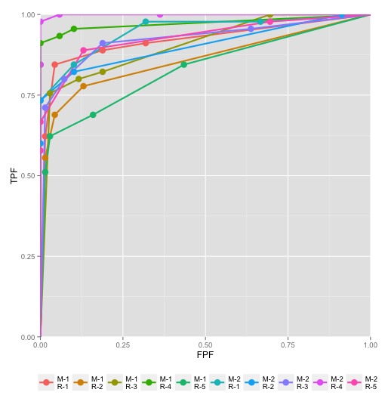

This plot shows the large variability in performance between the readers, which is one reason one needs to adequately sample the reader population. The following construct can be used to plot operating characteristics for each modality, averaged over readers.

plotMAvg <- list(1, 2)
plotRAvg <- list(c(1:5),c(1:5))
plotRocAvg <- EmpiricalOpCharac(dataset = rocData, modalities = plotMAvg, readers = plotRAvg, OpChType = "ROC")

This tells the function to create two plots, one per modality, where each plot is averaged over all 5 readers. The result is Fig. xx.

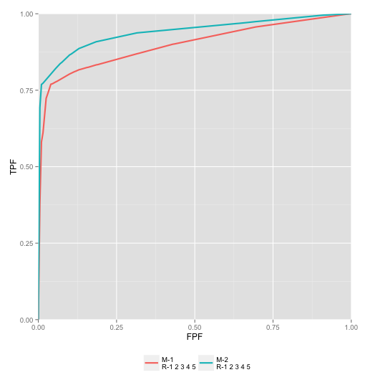

Free-response data visualization
The function EmpiricalOpCharac() can be used to plot trapezoidal ROC/AFROC/FROC curves. The following commands will create trapezoidal ROC curves for all 8 combinations of 2 modalities and 4 readers in frocData dataset, Fig. xx (a), and averaged ROC, Fig. xx (b), AFROC, Fig. xx (c) and FROC curves, Fig. xx (d).

plotM <- c(1:2)
plotR <- c(1:4)
EmpiricalOpCharac(data = frocData, modalities = plotM, readers = plotR, OpChType = "ROC")

plotMAvg <- list(1, 2)
plotRAvg <- list(c(1:4),c(1:4))
EmpiricalOpCharac(data = frocData, modalities = plotMAvg, readers = plotRAvg, OpChType = "ROC")

plotMAvg <- list(1, 2)
plotRAvg <- list(c(1:4),c(1:4))
EmpiricalOpCharac(data = frocData, modalities = plotMAvg, readers = plotRAvg, OpChType = "AFROC")

plotMAvg <- list(1, 2)
plotRAvg <- list(c(1:4),c(1:4))
EmpiricalOpCharac(data = frocData, modalities = plotMAvg, readers = plotRAvg, OpChType = "FROC")

Panel (a) does show, for each reader, coded by color, that the dotted lines are above the corresponding solid lines. This is confirmed in the averaged ROC, AFROC and FROC curves (panels b, c and d).

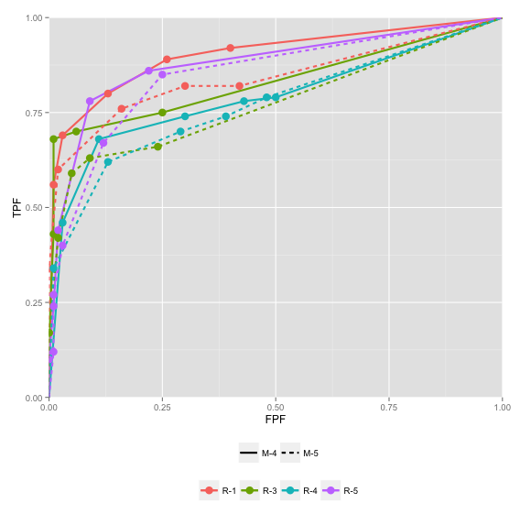 | 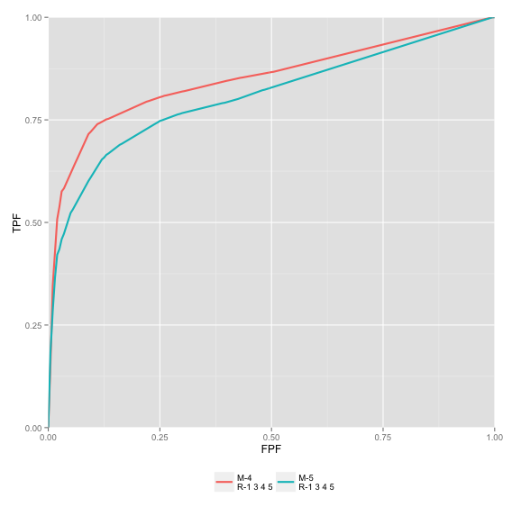
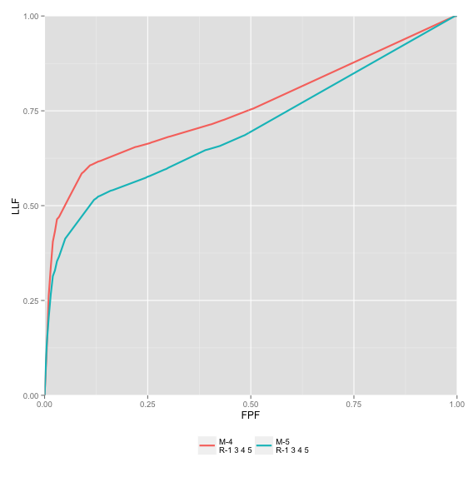 | 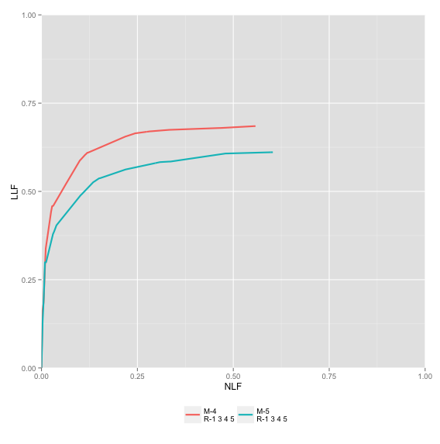

Note that the numbering of the readers is not sequential; the reader IDs are actually string labels, and in this dataset for some reason the experimenter chose not to use the sequential labels 1 - 4. Comparing panels (b) and (c) one can appreciate that the AFROC curve is below the corresponding ROC curve, and that the difference is areas is larger for the AFROC than the ROC. Panel (d) shows the averaged FROC curves; although used by some investigators, this is a poor summary of performance. Even the partial area under the FROC to the left of some defined abscissa value is not a good figure of merit^{55,62}, as it does not give credit for non-diseased images with no marks (these are actually high confidence correct decisions - i.e., perfect decisions).

Search model predicted operating characteristics

The search model predicts the ROC, AFROC and FROC curves. Additionally, it predicts the probability distribution functions of the highest rating on non-diseased and diseased cases. While unnecessary for data analysis, they give insight into the factors that affect observer performance in medical imaging tasks.

Table xx: Search model predicted effect ofparameter, for values ranging from 0 to 5 (in raster order, top-left to bottom-right) for , and one lesion per diseased case. The corresponding AUCs are 0.5, 0.634, 0.714, 0.880, 0.961, 0.983 and 0.996.
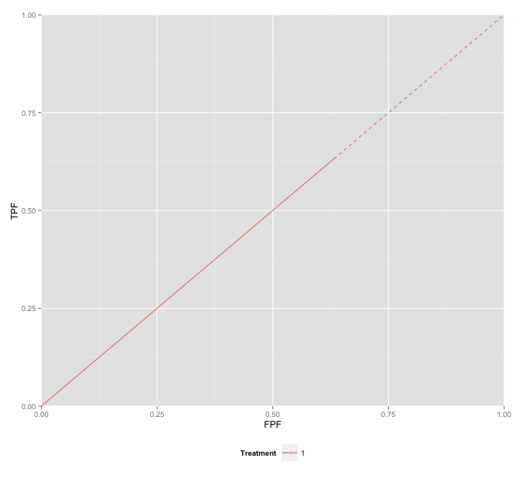 | 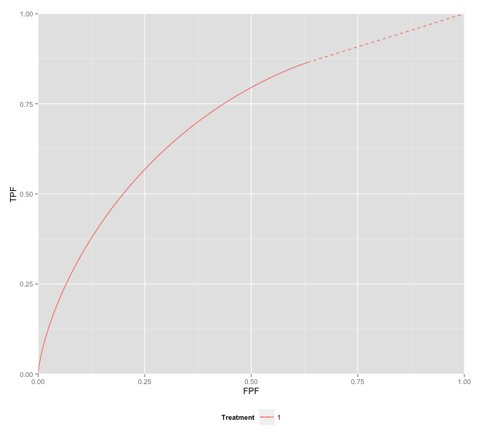
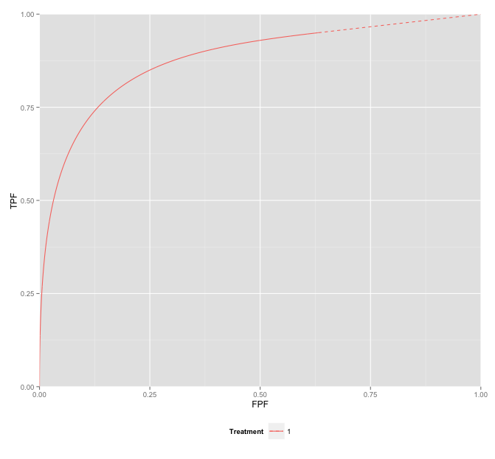 | 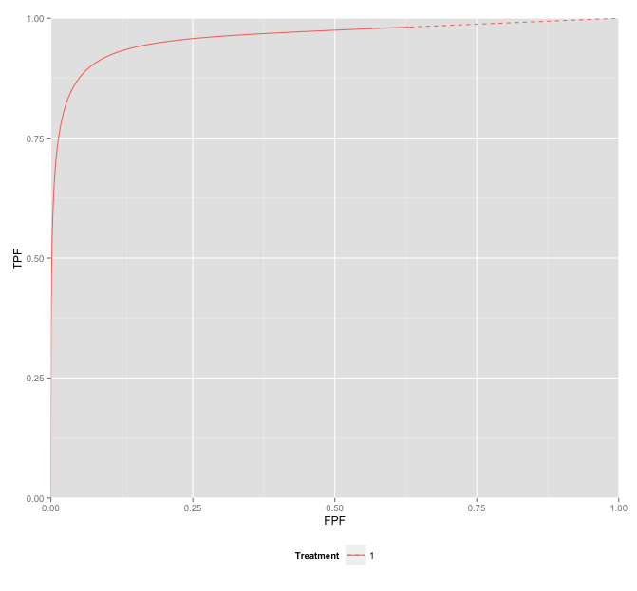
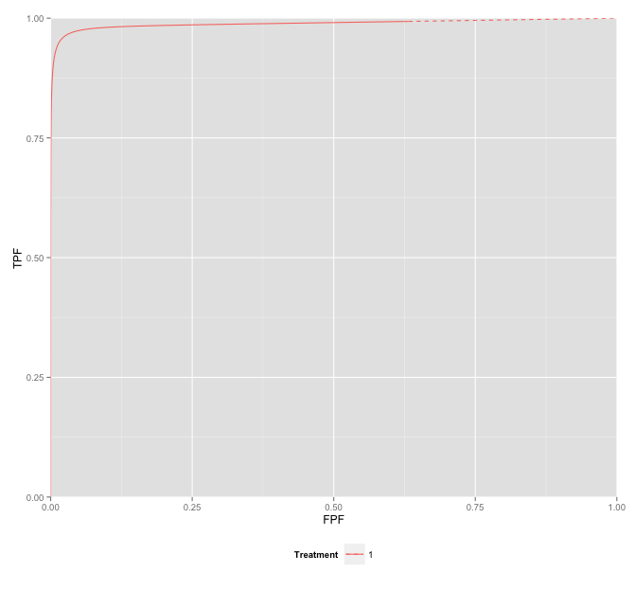 | 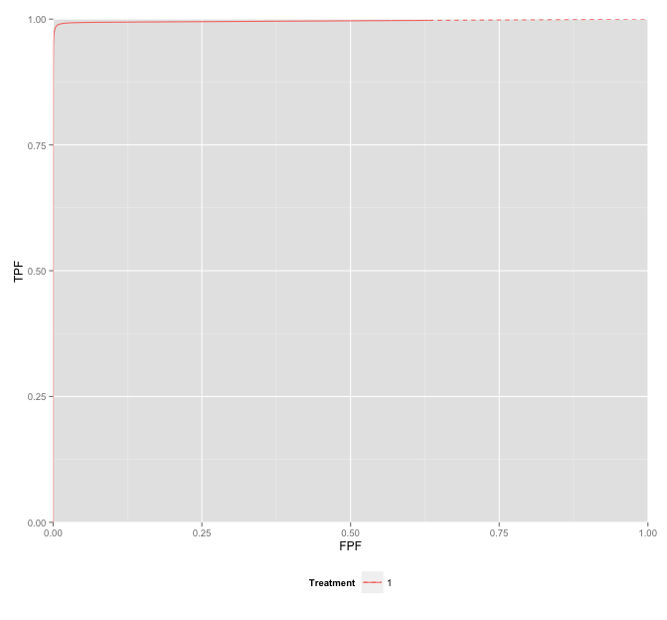

Table xx: Search model predicted effect ofparameter, for values ranging from 0 to 5 (in raster order, top-left to bottom-right) for , and one lesion per diseased case. The corresponding AUCs are 0.5, 0.880, 0.931, 0.938, 0.939 and 0.939.
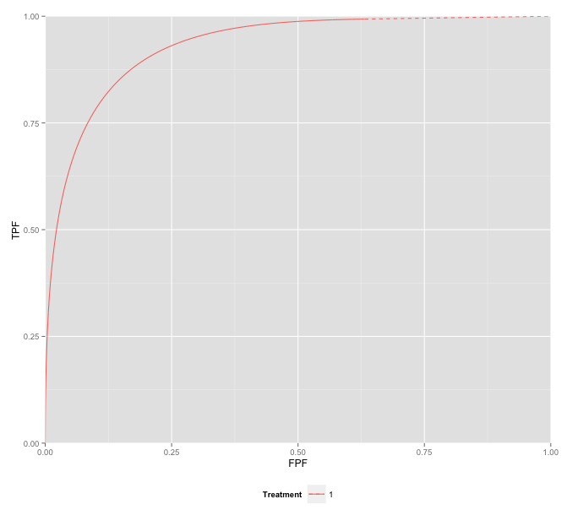 | 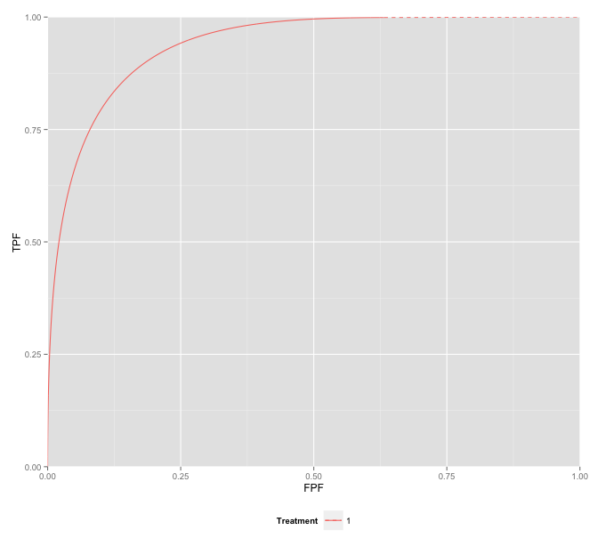
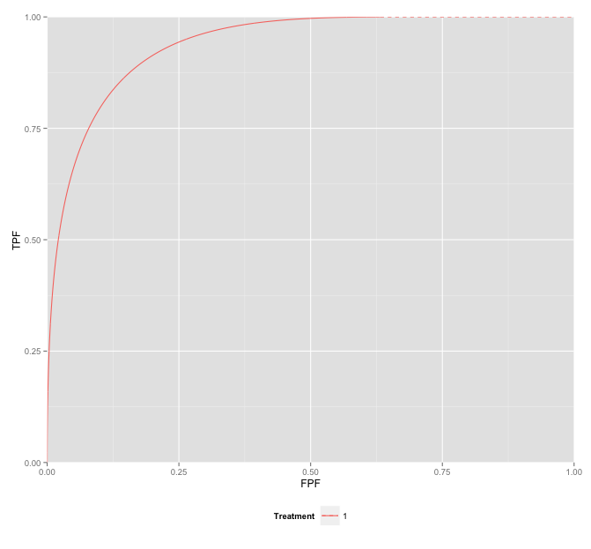 | 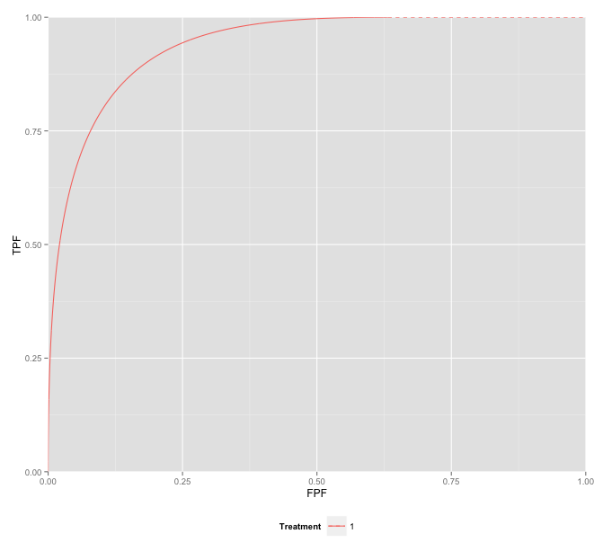

Table xx: Search model predicted effect ofparameter, for values ranging from 0 to 5 (in raster order, top-left to bottom-right) for , and one lesion per diseased case. The corresponding AUCs are 0.932, 0.880, 0.846 0.821, 0.803 and 0.787.
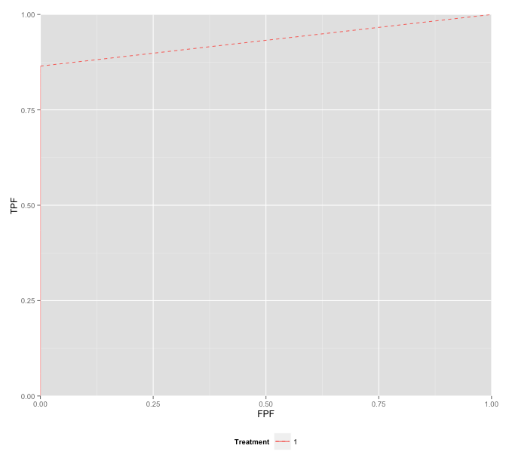
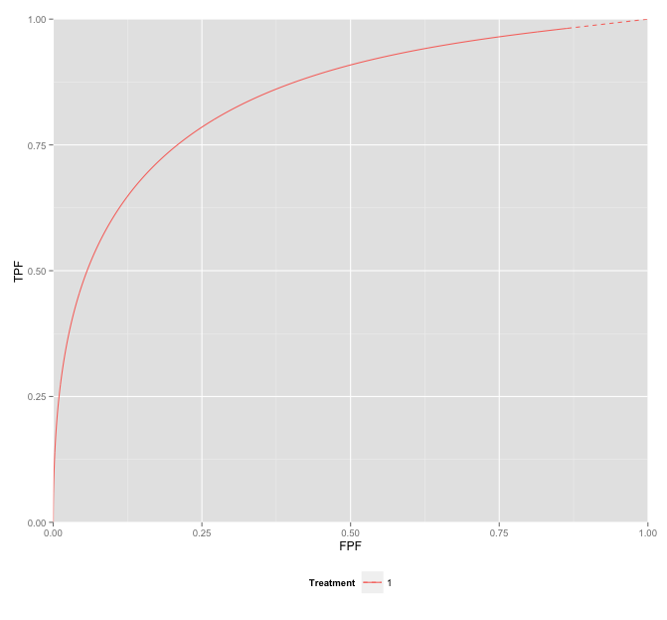 | 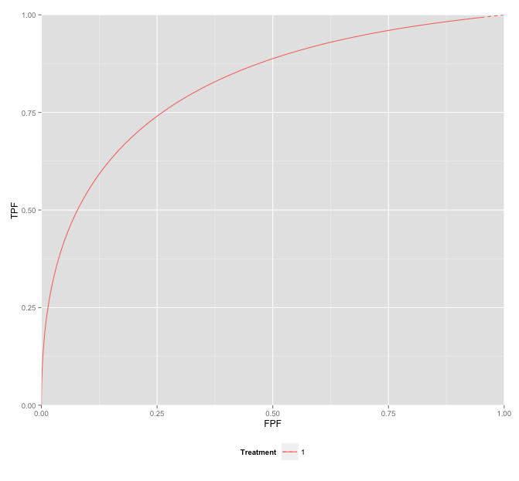
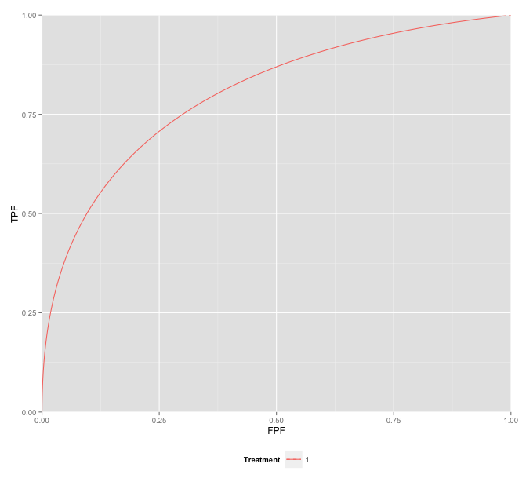 | 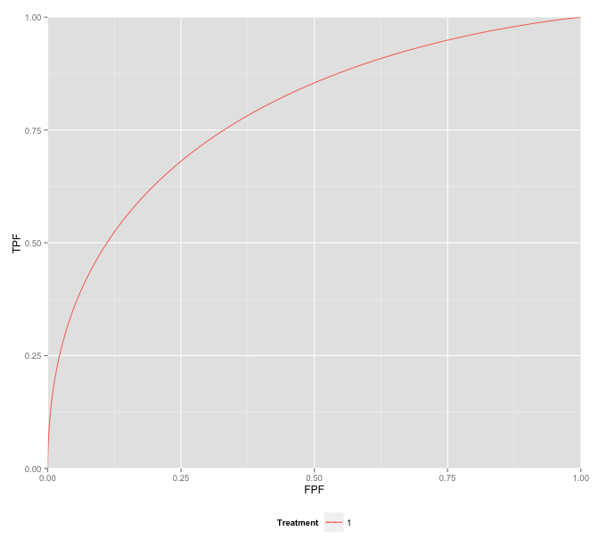

Table xx: Search model predicted effect of probability mass function of the lesion distribution parameter, for values ranging from 0 to 5 (in raster order, top-left to bottom-right) for and . The plots are for (1,0,0), (0.75,0.25,0), (0.5,0.5,0), (0.25,0.5,0), (0,1,0) and (0,0.5,0.5). The corresponding AUCs are 0.880, 0.900, 0.920, 0.941, 0.961 and 0.972.
 | 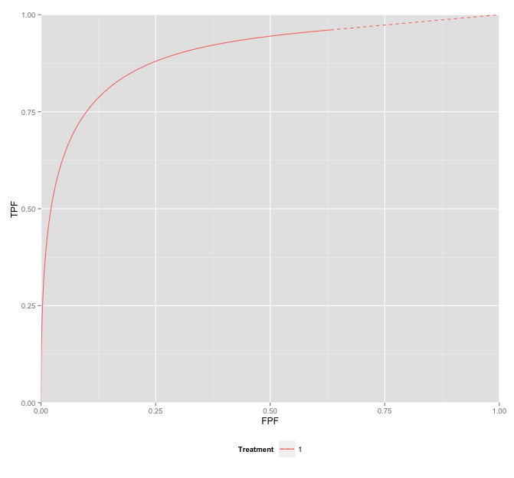
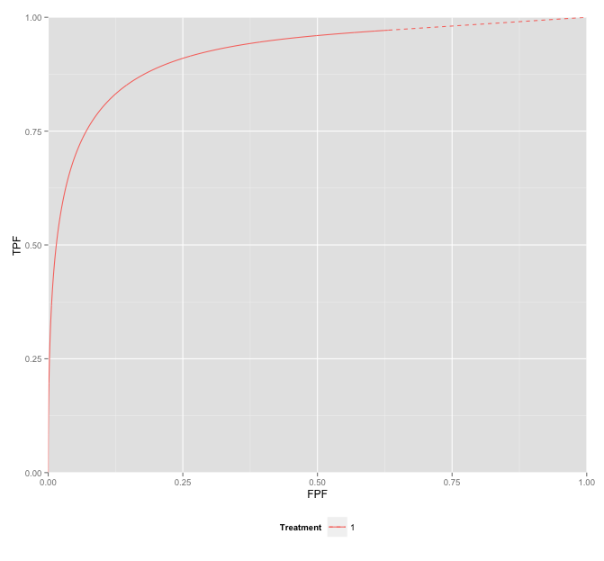 | 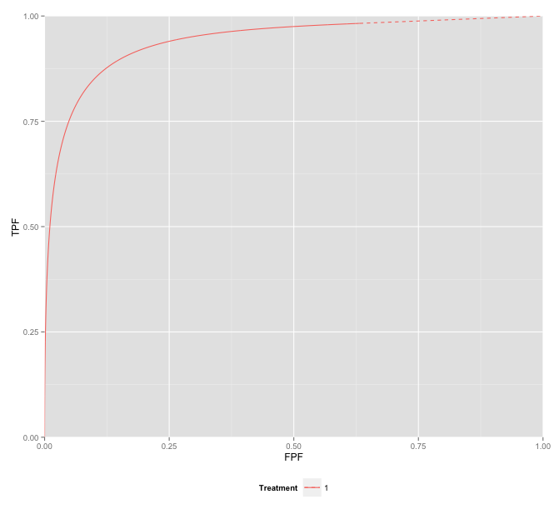
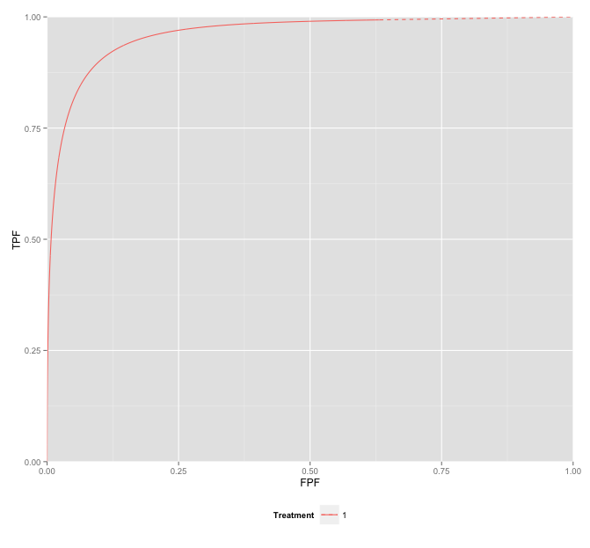 | 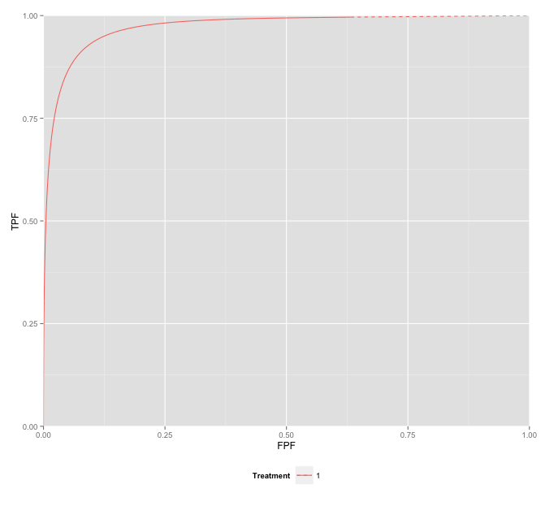

Software comparison
Table 8 compares the features and capabilities of existing online software and RJafroc: data file format, whether they are open-source, and if so, the programming language expertise needed to understand them, whether they are cross platform applications, whether individual modules can be called from other languages, whether they include integrated visualization routines, and the degree to which they accommodate location paradigms.

Table 8: Software capabilities comparison of available methods of analyzing observer performance data
Software | OR-DBM MRMC &  DBM-MRMC | iMRMC | JAFROC | RJafroc
Data entry | Plain text in specified format | Plain text in specified format | Excel file in JAFROC format | All text and Excel file formats
Open Source/Language | No/Fortran/C++ | Yes/Java | No/C++ | Yes/R
Cross platform | No | Yes | No | Yes
Call from other Languages | No | No | No | Yes
ROC curve fitting | Yes | No | No | No
Integrated data visualization capability | No | Yes | Yes | Yes
Localization paradigms (ROI and FROC) | No | No | Yes | Yes
Predicting search paradigm operating characteristics | No | No | Yes | Yes

Discussion

Advantages of RJafroc
In summary, RJafroc performs better than the others in following aspects.
- Programmabilty. Both of OR-DBM MRMC and iMRMC are GUI-based softwares, so it is almost impossible to call them and catch the results from users’ own program. RJafroc is distributed as a package of R. All functions in the package can be used in users’ own R code. Considering the good interactivity between R and other programming languages, RJafroc can also be easily called from programming environments other than R including but not limited to C/C++, Java, Python and MATLAB. In additional, RJafroc is an open source package. Users can find the source code of the package online, and it is convenient to debug and modify the source code if the original version cannot meet users’ specific requirements.
- Ability to Analyze Localization Data. JAFROC and RJafroc are the only available software for free-response studies, and RJafroc implements OR method for FROC data for the first time. Operating Characteristics is a useful tool to help users understand the effect of FROC parameters.
- Plotting Features RJafroc provides empirical and search model fitted parametric ROC/AFROC/FROC curves. The R package ggplot2 (Wickham 2009) is used to plot all these curves. It gives fancy layouts, colors and legends, and ggplot2 objects are easy
to be modified. Both the plotting data points and ggplot2 objects are returned. Users can output the data points then plot the curves using other tools, or modify the ggplot2 object as their own requirements.

Limitations and Potential Future Updates
RJafroc has limitations need to be improved in the future. There are also some more features should be useful to be added in the package. General ideas are given as follows.
- Running Speed. Since all the code of RJafroc are written using R and a lot of resampling operations (jackknife and bootstrap) are implemented by loops, the running time, especially for larger data file, is longer than that of the softwares written using “lower-level”languages such as C/C++. We are considering that convert some functions with many loop operations to C/C++ in the future. In the data import part, xlsx is used to read Excel file. The package provides the capibility to handle the operations to Excel fiel, but the running speed is slow. We are looking for a replacement of xlsx (Dragulescu 2014) to reduce the data reading time.
- Other Figure of Merit and Methods. Only AUC is used as the ROC analysis figure of merit and only search model is used to fit the curves. Other figure of merit and model should also be implemented and included in the future.
- Simulator. Simulation plays an important role in ROC/FROC researches. It is always used to validate a new statistical method. Hence the simulator design is very significant. We are planning to provide a simulator in RJafroc to help users generate simulation data.
- Graphical User Interface. GUI is necessary for some users, especially for the old users of JAFROC. An R based GUI package for RJafroc is in development. We will publish it when it is finished. JAFROC can be completely replaced at that time.

Conclusions
The RJafroc package is able to perform MRMC analysis of ROC/FROC/ROI data. The package provides OR and DBM methods for performing MRMC analysis, each of which can be used with different figures of merit. Sample size calculation helps to estimate sample size for given effect size and statistical power in future study. Through the cross validation between the analysis of same dataset by RJafroc and other softwares, the analysis results of RJafroc is reliable.
Empirical and parametric ROC/AFROC/FROC curves are also given by the package. Search model is used to fit the curves. Operating Characteristics shows the effect of search model parameters on the predicted ROC, AFROC and FROC curves. It is convenient to demonstrate how the parameters affect readers’ performance.
Through the provided examples, RJafroc will be definitely helpful if you are using R as a main programming language. Future version of this package will attempt to reduce the running time as well as provide more features.

Acknowledgments
Zanca, Berbaum,

Appendices

Other free-response figures of merit implemented in RJafroc
Free-response data can be used to infer maximum sensitivity and specificity, corresponding to the highest operating point on the ROC curve, excluding the trivial point at (1,1). These are defined by

The JAFROC FOM is defined as the probability that lesions are rated higher than the highest noise on normal images:

The corresponding JAFROC1 FOM, which includes the highest noise on abnormal images, is defined by

The maximum LLF figure of merit is defined by

The maximum NLF figure of merit is defined by

Here is x is finite and .

An exponentially transformed specificity figure of merit⁷⁰ is defined by:

These are summarized in Table 9:

Table 9:
Paradigm | Description of FOM | Symbol | Comments
FROC | Highest rating inferred sensitivity |  | Case-level inferred sensitivity
FROC | Highest rating inferred specificity |  | Case-level inferred specificity
FROC | Exponentially transformed specificity |  | Popescu suggestion
FROC | JAFROC |  | Does not use weighting
FROC | JAFROC1 |  | Does not use weighting
FROC | Maximum ordinate of FROC |  | Lesion-level "sensitivity"
FROC | Maximum abscissa of FROC |  | Lesion-level "inverse specificity", lower values preferred

Special cases of DBMH analysis

Fixed-reader random-case (FRRC) analysis
When readers are treated as a fixed effect, the appropriate F statistic for testing the null hypothesis is

This is distributed as an F statistic with ndf = I -1, and ddf = (I - 1)(K - 1):

The critical value of the statistic is which is that value such that fraction of the distribution lies to the left of the critical value. The null hypothesis is rejected if the observed value of the F statistic exceeds the critical value:

.

The p-value of the test is the probability that a random sample from the distribution exceeds the observed value:

The confidence interval is given by:

Random-reader fixed case (RRFC) analysis
When cases are treated as a fixed effect, the appropriate F statistic for testing the null hypothesis is

This is distributed as an F statistic with ndf = I - 1, and ddf = (I - 1)(J - 1):

The critical value of the statistic is which is that value such that fraction of the distribution lies to the left of the critical value. The null hypothesis is rejected if the observed value of the F statistic exceeds the critical value:

.

The p-value of the test is the probability that a random sample from the distribution exceeds the observed value:

The confidence interval is given by:

Special cases of ORH analysis

Fixed-reader random-case (FRRC) analysis
When readers are treated as a fixed effect, the appropriate F statistic for testing the null hypothesis is

This is distributed as an F statistic with ndf = I-1, and ddf = infinity, or equivalently a chi-square distribution with I-1 degrees of freedom:

The critical value of the statistic is which is that value such that fraction of the distribution lies to the left of the critical value. The null hypothesis is rejected if the observed value of the F statistic exceeds the critical value:

.

The p-value of the test is the probability that a random sample from the distribution exceeds the observed value:

The confidence interval is given by:

Random-reader fixed case (RRFC) analysis
When cases are treated as a fixed effect, the appropriate F statistic for testing the null hypothesis is:

This is distributed as:

The critical value of the statistic is which is that value such that fraction of the distribution lies to the left of the critical value. The null hypothesis is rejected if the observed value of the F statistic exceeds the critical value:

.

The p-value of the test is the probability that a random sample from the distribution exceeds the observed value:

The confidence interval is given by:

Details of ROI simulator
Since it is based on the Roe-Metz simulator for ROC data, we begin by describing the ROC data simulator for MRMC studies. For each modality, it consists of two unit variance distributions separated by an amount that determines AUC in that modality. The readers and cases are modeled by random samples and there is an error term that depends on treatments, readers and cases. The Roe and Metz model is⁷¹:

The fixed effects in the simulator are described by

The random effects are described by

To preserve the unit variance character of the model, the following constraint is applied:

Since ROI data is a special case of FROC data, we denote the ROI rating by where on non-diseased cases, where is the number of ROIs (or "quadrants") on every case, and on diseased cases , where is the number of diseased ROIs on diseased case , and on diseased case .
The ROI model is defined by:

The idea is to split up each term containing the case factor into two terms, one containing the case factor, and the other an additional location factor L (for location) with levels defined by , such that the net case variance is unaltered. The following two terms do not contain the case factor and hence do not need to be split.

The following term containing only the case factor is split up as follows [the term () controls the correlation between the samples from the different locations on the same case]:

Likewise, the treatment-case factor is split up as follows:

The reader-case factor is split up as follows:

Finally, the error term is split up as follows:

For the simulated data the following values, selected from Table 1 in the Roe and Metz paper, were used:

The correlation parameters were set as follows:

References
1. Metz CE. ROC Methodology in Radiologic Imaging. Investigative Radiology. 1986;21(9):720-733.
2. Pisano ED, Gatsonis C, Hendrick E, et al. Diagnostic performance of digital versus film mammography for breast-cancer screening. N Engl J Med. 2005 2005;353(17):1-11.
3. Chakraborty DP, Berbaum KS. Observer studies involving detection and localization: Modeling, analysis and validation. Med Phys. 2004;31(8):2313-2330.
4. Chakraborty DP. A Brief History of Free-Response Receiver Operating Characteristic Paradigm Data Analysis. Academic Radiology. 7// 2013;20(7):915-919.
5. Metz CE. Basic principles of ROC analysis. Seminars in Nuclear Medicine. 1978;8(4):283-298.
6. Metz CE. Some Practical Issues of Experimental Design and Data Analysis in Radiological ROC studies. Investigative Radiology. 1989;24:234-245.
7. Metz C. ROC analysis in medical imaging: a tutorial review of the literature. Radiological Physics and Technology. 2008;1(1):2-12.
8. Wagner RF, Beiden SV, Campbell G, Metz CE, Sacks WM. Assessment of medical imaging and computer-assist systems: lessons from recent experience. Academic Radiology. Nov 2002;9(11):1264 -1277.
9. Wagner RF, Metz CE, Campbell G. Assessment of Medical Imaging Systems and Computer Aids: A Tutorial Review. Acad Radiol. 2007;14(6):723-748.
10. Kundel HL, Berbaum KS, Dorfman DD, Gur D, Metz CE, Swensson RG. Receiver Operating Characteristic Analysis in Medical Imaging (ICRU Report 79). International Commission on Radiation Units & Measurments;2008.
11. Dorfman DD, Alf E. Maximum likelihood estimation of parameters of signal detection theory- a direct solution. Psychometrika. 1968;33(1):117-124.
12. Dorfman DD, Alf E. Maximum-Likelihood Estimation of Parameters of Signal-Detection Theory and Determination of Confidence Intervals - Rating-Method Data. Journal of Mathematical Psychology. 1969 1969;6:487-496.
13. Dorfman DD, Berbaum KS. RSCORE-J: Pooled rating-method data: A computer program for analyzing pooled ROC curves. Behavior Research Methods, Instruments, & Computers. 1986;18(5):452-462.
14. Dorfman DD, Berbaum KS, Metz CE, Lenth RV, Hanley JA, Abu Dagga H. Proper Receiving Operating Characteristic Analysis: The Bigamma model. Acad. Radiol. 1997;4(2):138-149.
15. Dorfman DD, Berbaum KS. A contaminated binormal model for ROC data: Part II. A formal model. Acad Radiol. 2000;7(6):427-437.
16. Pan X, Metz CE. The proper binormal model: parametric receiver operating characteristic curve estimation with degenerate data. Acad. Radiol. 1997;4(5):380-389.
17. Metz CE, Pan X. Proper Binormal ROC Curves: Theory and Maximum-Likelihood Estimation. J Math Psychol. 1999;43(1):1-33.
18. Pesce LL, Metz CE. Reliable and Computationally Efficient Maximum-Likelihood Estimation of Proper Binormal ROC Curves. Acad Radiol. 2007;14(7):814-829.
19. Hanley JA, McNeil BJ. The meaning and use of the area under a receiver operating characteristic (ROC) curve. Radiology. April 1, 1982 1982;143(1):29-36.
20. Wilcoxon F. Individual Comparison by Ranking Methods. Biometrics. 1945;1:80-83.
21. Mann HB, Whitney DR. On a test of whether one of two random variables is stochastically larger than the other. Annals of Mathematical Statistics. 1947;18:50−60.
22. Metz CE, Herman BA, Roe CE. Statistical Comparison of Two ROC-curve Estimates Obtained from Partially-paired Datasets. Med Decis Making. 1998;18(1):110-121.
23. Obuchowski N. Reducing the Number of Reader Interpretations in MRMC Studies. Acad Radiol. 2009;16:209–217.
24. Obuchowski NA, Mazzone PJ, Dachman AH. Bias, underestimation of risk, and loss of statistical power in patient-level analyses of lesion detection. Eur Radiol. 2010;20:584–594.
25. Swensson RG, Judy PF. Detection of noisy visual targets: Models for the effects of spatial uncertainty and signal-to-noise ratio. Perception & Psychophyics. 1981;29(6):521-534.
26. Starr SJ, Metz CE, Lusted LB. Comments on generalization of Receiver Operating Characteristic analysis to detection and localization tasks. Phys. Med. Biol. 1977;22:376-379.
27. Starr SJ, Metz CE, Lusted LB, Goodenough DJ. Visual detection and localization of radiographic images. Radiology. 1975;116:533-538.
28. Swensson RG. Unified measurement of observer performance in detecting and localizing target objects on images. Med. Phys. 1996;23(10):1709 -1725.
29. Egan JP, Greenburg GZ, Schulman AI. Operating characteristics, signal detectability and the method of free response. J Acoust Soc. Am. 1961;33:993-1007.
30. Miller H. The FROC curve: a representation of the observer's performance for the method of free response. The Journal of the Acoustical Society of America. 1969;46(6(2)):1473-1476.
31. Bunch PC, Hamilton JF, Sanderson GK, Simmons AH. A Free-Response Approach to the Measurement and Characterization of Radiographic-Observer Performance. J of Appl Photogr. Eng. 1978;4(4):166-171.
32. Chakraborty DP. Maximum Likelihood analysis of free-response receiver operating characteristic (FROC) data. Med. Phys. 1989;16(4):561-568.
33. Chakraborty DP, Winter LHL. Free-Response Methodology: Alternate Analysis and a New Observer-Performance Experiment. Radiology. 1990;174:873-881.
34. Chakraborty DP, Breatnach ES, Yester MV, Soto B, Barnes GT, Fraser RG. Digital and Conventional Chest Imaging: A Modified ROC Study of Observer Performance Using Simulated Nodules. Radiology. 1986;158:35-39.
35. Niklason LT, Hickey NM, Chakraborty DP, et al. Simulated Pulmonary Nodules: detection with Dual-Energy Digital versus Conventional Radiography. Radiology. 1986;160:589-593.
36. Barnes GT, Sabbagth EA, Chakraborty DP, et al. A comparison of dual-energy digital radiography and screen-film imaging in the detection of subtle interstitial pulmonary disease. Invest Radiol. 1989;24(8):585-591.
37. Obuchowski NA, Lieber ML, Powell KA. Data Analysis for Detection and Localization of Multiple Abnormalities with Application to Mammography. Acad. Radiol. 2000;7(7):516-525.
38. Dorfman DD, Berbaum KS, Metz CE. ROC characteristic rating analysis: Generalization to the Population of Readers and Patients with the Jackknife method. Invest. Radiol. 1992;27(9):723-731.
39. Obuchowski NA, Rockette HE. Hypothesis Testing of the Diagnostic Accuracy for Multiple Diagnostic Tests: An ANOVA Approach with Dependent Observations. Communications in Statistics: Simulation and Computation. 1995;24:285-308.
40. Gallas BD. One-Shot Estimate of MRMC Variance: AUC. Academic Radiology. 2006;13(3):353-362.
41. Gallas BD, Bandos A, Samuelson FW, Wagner RF. A Framework for Random-Effects ROC Analysis: Biases with the Bootstrap and Other Variance Estimators. Communications in Statistics - Theory and Methods. 2009;38(15):2586 - 2603.
42. Toledano AY, Gatsonis C. Ordinal regression methodology for ROC curves derived from correlated data. Stat Med. 1996;15(16):1807-1826.
43. Toledano AY. Three methods for analyzing correlated ROC curves: A comparison in real data sets. Statistics in Medicine. Sept 30 2003;22(18):2919-2933.
44. Song HH. Analysis of correlated ROC areas in diagnostic testing. Biometrics. 1997;53:370-382.
45. Ishwaran H, Gatsonis CA. A General Class of Hierarchical Ordinal Regression Models with Applications to Correlated ROC Analysis. The Canadian Journal of Statistics. 2000;28(4):731-750.
46. Obuchowski NA, Beiden SV, Berbaum KS, et al. Multireader, Multicase Receiver Operating Characteristic Analysis: An Empirical Comparison of Five Methods. Acad. Radiol. 2004;11(9):980-995.
47. Beiden SV, Wagner RF, Campbell G. Components-of Variance Models and Multiple-Bootstrap Experiments: An Alternative Method for Random-Effects, Receiver Operating Characteristic Analysis. Academic Radiology. 2000;7(5):341-349.
48. Chakraborty DP. ROC Curves predicted by a model of visual search. Phys. Med. Biol. 2006;51:3463–3482.
49. Chakraborty DP. A search model and figure of merit for observer data acquired according to the free-response paradigm. Phys. Med. Biol. 2006;51:3449–3462.
50. Kundel HL, Nodine CF, Krupinski EA, Mello-Thoms C. Using Gaze-tracking Data and Mixture Distribution Analysis to Support a Holistic Model for the Detection of Cancers on Mammograms. Academic Radiology. 2008;15(7):881-886.
51. Kundel HL, Nodine CF, Conant EF, Weinstein SP. Holistic Component of Image Perception in Mammogram Interpretation: Gaze-tracking Study. Radiology. 2007;242(2):396-402.
52. Kundel HL, Nodine CF. Modeling visual search during mammogram viewing. Proc. SPIE. 2004;5372:110-115.
53. Gregory RL. The Intelligent Eye. New York, NY.: McGraw-Hill; 1970.
54. Rock I. Perception. New York, NY: WH Freeman and Company; 1984.
55. Wolfe JM. Visual Search. In: Pashler H, ed. Attention. London, UK: University College London Press; 1998.
56. Wolfe JM. Guided Search 2.0: A revised model of visual search. Psychonomic Bulletin & Review. 1994;1(2):202-238.
57. Bamber D. The area above the ordinal dominance graph and the area below the receiver operating characteristic graph. Journal of Mathematical Psychology. 1975;12(4):387-415.
58. Song T, Bandos AI, Rockette HE, Gur D. On comparing methods for discriminating between actually negative and actually positive subjects with FROC type data. Medical Physics. 2008;35(4):1547-1558.
59. Obuchowski NA. Nonparametric Analysis of Clustered ROC Curve Data. Biometrics. 1997;53:567-578.
60. Hillis SL. A comparison of denominator degrees of freedom methods for multiple observer ROC studies. Statistics in Medicine. 2007;26:596-619.
61. Efron B, Tibshirani RJ. An Introduction to the Bootstrap. Vol 57. Boca Raton: Chapman & Hall/CRC; 1993.
62. DeLong ER, DeLong DM, Clarke-Pearson DL. Comparing the Areas Under Two or More Correlated Receiver Operating Characteristic Curves: A Nonparametric Approach. Biometrics. 1988;44:837-845.
63. Hillis SL, Obuchowski NA, Berbaum KS. Power Estimation for Multireader ROC Methods: An Updated and Unified Approach. Academic Radiology. 2011;18(2):129-142.
64. Press WH, Teukolsky SA, Vetterling WT, Flannery BP. Numerical Recipes: The Art of Scientific Computing. 3 ed. Cambridge: Cambridge University Press; 2007.
65. Chakraborty DP, Yoon HJ. Operating characteristics predicted by models for diagnostic tasks involving lesion localization. Med. Phys. 2008;35(2):435-445.
66. Van Dyke CW, White RD, Obuchowski NA, Geisinger MA, Lorig RJ, Meziane MA. Cine MRI in the diagnosis of thoracic aortic dissection. 79th RSNA Meetings. 1993.
67. Zanca F, Jacobs J, Van Ongeval C, et al. Evaluation of clinical image processing algorithms used in digital mammography. Medical Physics. 2009;36(3):765-775.
68. Chakraborty DP. Validation and Statistical Power Comparison of Methods for Analyzing Free-response Observer Performance Studies. Acad Radiol. 2008;15(12):1554-1566.
69. Chakraborty DP. Statistical power in observer performance studies: A comparison of the ROC and free-response methods in tasks involving localization. Acad. Radiol. Feb 2002;9(2):147-156.
70. Popescu LM. Nonparametric signal detectability evaluation using an exponential transformation of the FROC curve. Medical Physics. 2011;38(10):5690-5702.
71. Roe CA, Metz CE. Dorfman-Berbaum-Metz Method for Statistical Analysis of Multireader, Multimodality Receiver Operating Characteristic Data: Validation with Computer Simulation. Acad Radiol. 1997;4:298-303.

